Year 12 Acids and Bases 2

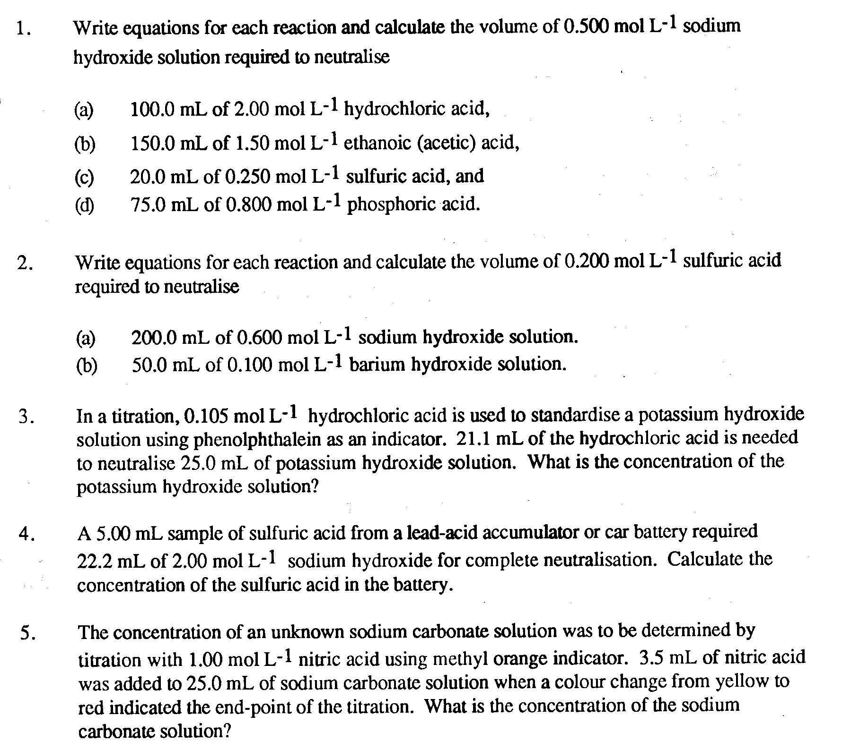
(16 marks)

(8 marks)

(4 marks)

(4 marks)

(4 marks)

